|  |  |  |  |  |  |  |  |  |
| --- | --- | --- | --- | --- | --- | --- | --- | --- |
| **HOST NEEDED** | **AVAILABLE HOST** | **NETWORK ADDRESS** | **FIRST IP** | **LAST IP** | **BROADCAST ADDRESS** | **SLASH** | **SUBNET MASK** | **WILDCARD ADDRESS** |
|  |  |  |  |  |  |  |  |  |
| **400** | 510 | 27.0.0.0 | 27.0.0.1 | 27.0.1.254 | 27.0.1.255 | /23 | 255.255.254.0 | 0.0.1.255 |
| **200** | 254 | 27.0.2.0 | 27.0.2.1 | 27.0.2.254 | 27.0.2.255 | /24 | 255.255.255.0 | 0.0.0.255 |
| **100** | 126 | 27.0.3.0 | 27.0.3.1 | 27.0.3.126 | 27.0.3.127 | /25 | 255.255.255.128 | 0.0.0.127 |
| **90** | 126 | 27.0.3.128 | 27.0.3.129 | 27.0.3.254 | 27.0.3.255 | /25 | 255.255.255.128 | 0.0.0.127 |
| **70** | 126 | 27.0.4.0 | 27.0.4.1 | 27.0.4.126 | 27.0.4.127 | /25 | 255.255.255.128 | 0.0.0.127 |
| **60** | 62 | 27.0.4.128 | 27.0.4.129 | 27.0.4.190 | 27.0.4.191 | /26 | 255.255.255.192 | 0.0.0.63 |
| **50** | 64 | 27.0.4.192 | 27.0.4.193 | 27.0.4.254 | 27.0.4.255 | /26 | 255.255.254.192 | 0.0.0.63 |
| **30** | 30 | 27.0.5.0 | 27.0.5.1 | 27.0.5.30 | 27.0.5.31 | /27 | 255.255.255.224 | 0.0.0.31 |
| **10** | 14 | 27.0.5.32 | 27.0.5.33 | 27.0.5.46 | 27.0.5.47 | /28 | 255.255.255.240 | 0.0.0.15 |
| **5** | 6 | 27.0.5.48 | 27.0.5.49 | 27.0.5.54 | 27.0.5.55 | /29 | 255.255.255.248 | 0.0.0.7 |
| **2** | 2 | 27.0.5.56 | 27.0.5.57 | 27.0.5.58 | 27.0.5.59 | /30 | 255.255.255.252 | 0.0.0.3 |
| **FOR ALL ROUTERS** | | | | | | | | |
| 2 | 2 | 27.0.5.60 | 27.0.5.61 | 27.0.5.62 | 27.0.5.63 | /30 | 255.255.255.252 | 0.0.0.3 |
| 2 | 2 | 27.0.5.64 | 27.0.5.65 | 27.0.5.66 | 27.0.5.67 | /30 | 255.255.255.252 | 0.0.0.3 |
| 2 | 2 | 27.0.5.68 | 27.0.5.69 | 27.0.5.70 | 27.0.5.71 | /30 | 255.255.255.252 | 0.0.0.3 |
| 2 | 2 | 27.0.5.72 | 27.0.5.73 | 27.0.5.74 | 27.0.5.75 | /30 | 255.255.255.252 | 0.0.0.3 |
| 2 | 2 | 27.0.5.76 | 27.0.5.77 | 27.0.5.78 | 27.0.5.79 | /30 | 255.255.255.252 | 0.0.0.3 |
| 2 | 2 | 27.0.5.80 | 27.0.5.81 | 27.0.5.82 | 27.0.5.83 | /30 | 255.255.255.252 | 0.0.0.3 |
| 2 | 2 | 27.0.5.84 | 27.0.5.85 | 27.0.5.86 | 27.0.5.87 | /30 | 255.255.255.252 | 0.0.0.3 |
| 2 | 2 | 27.0.5.88 | 27.0.5.89 | 27.0.5.90 | 27.0.5.91 | /30 | 255.255.255.252 | 0.0.0.3 |
| 2 | 2 | 27.0.5.92 | 27.0.5.93 | 27.0.5.94 | 27.0.5.95 | /30 | 255.255.255.252 | 0.0.0.3 |
| 2 | 2 | 27.0.5.96 | 27.0.5.97 | 27.0.5.98 | 27.0.5.99 | /30 | 255.255.255.252 | 0.0.0.3 |
| 2 | 2 | 27.0.5.100 | 27.0.5.101 | 27.0.5.102 | 27.0.5.103 | /30 | 255.255.255.252 | 0.0.0.3 |
| 2 | 2 | 27.0.5.104 | 27.0.5.105 | 27.0.5.106 | 27.0.5.107 | /30 | 255.255.255.252 | 0.0.0.3 |

**SBNETTING VLSM**

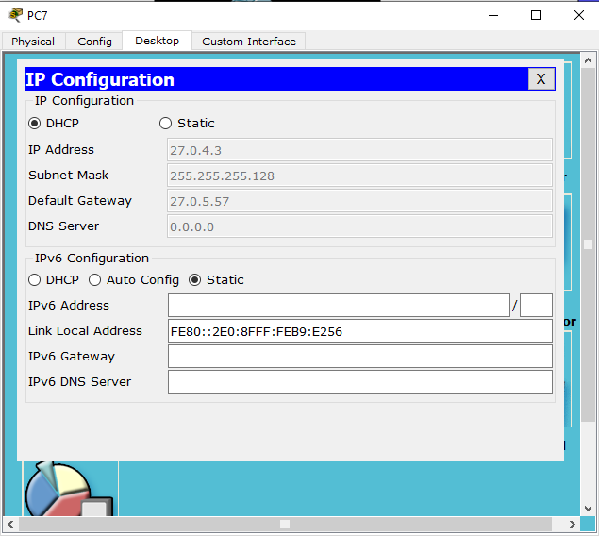**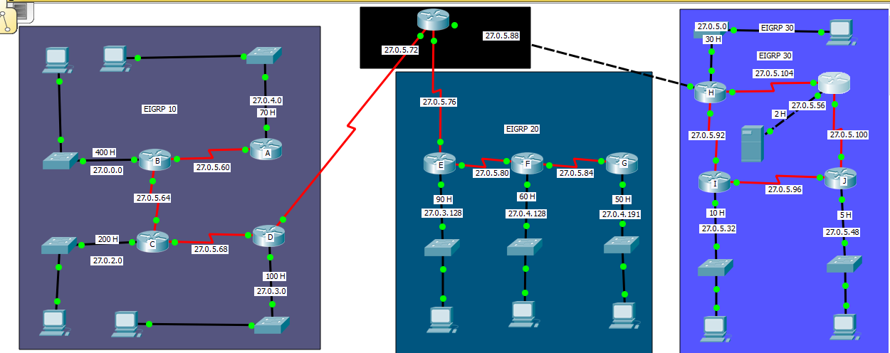SCREEN SHOTS**

**ROUTING TABLE**